Name:

Date:

Period:

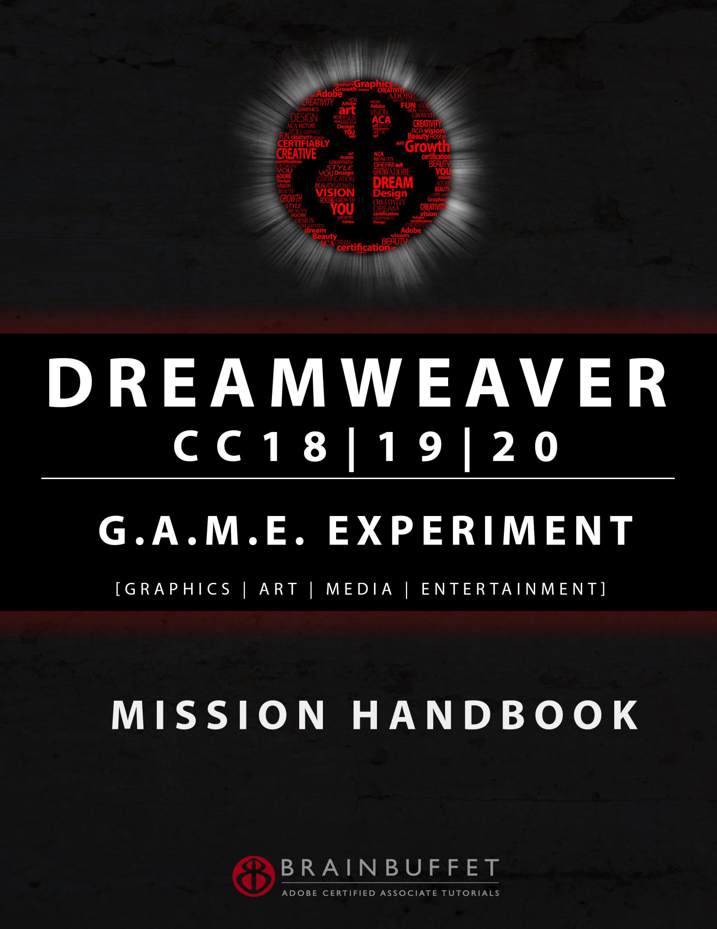

_____

[Year]

BrainBuffet Dreamweaver CC18|19|20 Student Packet

[DOCUMENT SUBTITLE]

CC LICENSE BY-NC-SA

 **DREAMWEAVER CC18|19|20 GAMER MISSION HANDBOOK**

Freely use and copy this unmodified workbook with this footer intact. Videos at brainbuffet.com

**Page 1**

Name: ________________________________________________________ Date: _____________ Period: _________

**DREAMWEAVER CC18|19|20 GAMER MISSION HANDBOOK**

Freely use and copy this unmodified workbook with this footer intact. Videos at brainbuffet.com

**Page 30**

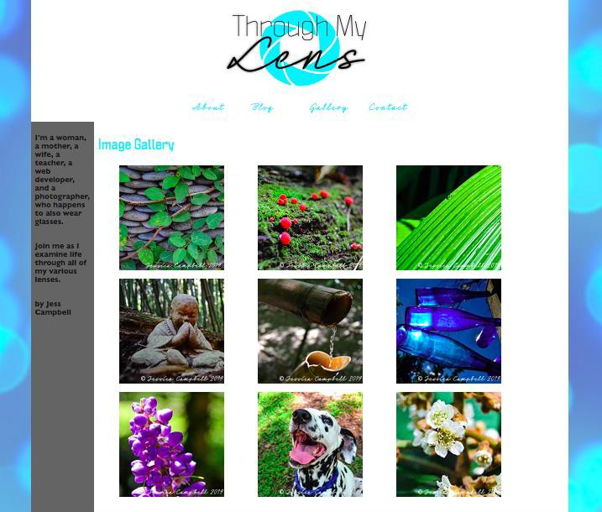

**Project 3 – Responsive Design**

**Dreamweaver CC18|19|20 Project 3**

CheckmarkCloseCheckmarkClose

# Dreamweaver CC18|19|20 Project 3 S.E.T.

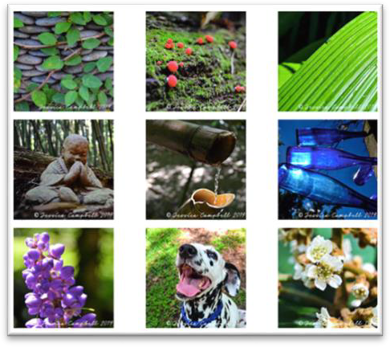**cenario:** *All businesses need a website, but it’s important to remember that a huge portion of web traffic is through mobile phones, not desktop*

**S**

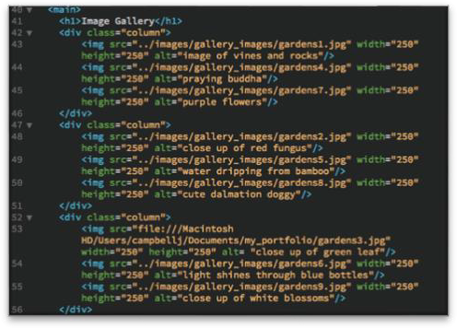*computers. Some consumers only have access to the internet via their phones! And a phone screen is a lot smaller than a computer screen. In order to be a successful web developer, you need to master the skill of responsive design, which will allow your webpage design to detect the size of the browser it’s being used on, and adjust itself to fit. This allows all of your visitors to view your page content, whether they’re at home or on the go!*

**xpectations:** Create a responsive image gallery for your website.

**E**

**imeline**: This should take you 4-5 hours of class time to complete.

**T**

|  |  |
| --- | --- |
| **Make sure to finish your BrainBuffet P.L.A.T.E.** for every day you’re working on a tutorial!  (Progress Learning, Activity, Timestamp, Experience.) | |
| **Day 1 Date:** | **Day 2 Date:** |
| Videos Completed:  Screenshots to document progress? What was the coolest thing you learned? | Videos Completed:  Screenshots to document progress? What was the coolest thing you learned? |

CheckmarkCloseCheckmarkCloseCheckmarkCloseCheckmarkClose

|  |  |
| --- | --- |
| **Make sure to finish your BrainBuffet P.L.A.T.E.** for every day you’re working on a tutorial!  (Progress, Learning, Activity, Timestamp, Experience.) | |
| **Day 3 Date:** | **Day 4 Date:** |
| Videos Completed:  Screenshots to document progress? What was the coolest thing you learned? | Videos Completed:  Screenshots to document progress? What was the coolest thing you learned? |
| **Day 5 Date:** | **Day 6 Date:** |
| Videos Completed:  Screenshots to document progress? What was the coolest thing you learned? | Videos Completed:  Screenshots to document progress? What was the coolest thing you learned? |

# Dreamweaver CC18|19|20 Project 3 Worksheets

**NOTES: Using the BrainBuffet Project 3 tutorials, please answer the following questions. Key vocabulary terms are in *bold!***

1. Explain why using **page templates** is helpful when designing a website? (3.01) Using page templates help other use your page without them messing it up.
2. How do Dreamweaver’s editable template regions work? (3.01) The editable template is used so you can edit that only region.
3. Describe three different ways you can create a new div using Dreamweaver’s

interface? (3.02)

* 1. Insert panel
  2. Insert menu
  3. DOM panel

1. Why is it important to use the Dreamweaver Files panel to rearrange files in your site

folder, instead of your system’s file viewer? (3.02) If done in the finder, the links will become broken and not show up properly

1. Why did we use a **class selector** (.column) to make the CSS rule for the columns, instead of an **ID selector** (#column) or **element selector** (div) (3.03)? It’s only going to affect that div and leave the other divs that aren’t using that class alone
2. List each of the five values of the CSS **position** property and a description of what each does. (3.04)

|  |  |
| --- | --- |
| **Value** | **Description** |
| **position: static;** | The default CSS position. Box shows up normally in the flow of your HTML elements. |
| **position: relative;** | The elements are positioned relatively to its original static position. |
| **position: absolute;** | Appear in a specific location in the browser window, ignoring all other HTML elements. |
| **position: fixed;** | These elements stand in a specific spot and don’t move or scroll with the rest of the page. |
| **position: sticky;** | Elements scroll with the page until the target location is reached. Then the element sticks in that spot. |

1. Explain what the term **responsive design** means in web development. (3.05) The website you create should be able to adjusts its layout in response to the browser’s size.
2. How does a **media query** work to make a web page responsive? (3.05) When applying a media query you can add custom CSS rules that only apply when the media query gets activated.
3. Fill in the blanks below to complete the media query so that the CSS rules inside only

apply when the viewport is larger than 600px wide. (3.05)

@media ( min-width: 600px) {

body {

background-color: blue;

}

1. Describe two places you can create media queries using Dreamweaver’s interface.

(3.05, 3.07)

* 1. On the Media Query Bar
  2. In the CSS Designer Panel

1. What CSS property can make an HTML element invisible? (3.07) display: none;
2. Explain the difference between **block** and **inline** HTML elements. What does the CSS

**display** property allow you to do? (3.07) It allows you to “override” the code you have in the CSS to change it to whatever you need it to display.

1. Describe the process of replacing a **placeholder image** with a different image file. (3.08) You change the image by going to the folder next to the image and use choose the image in your finder.
2. 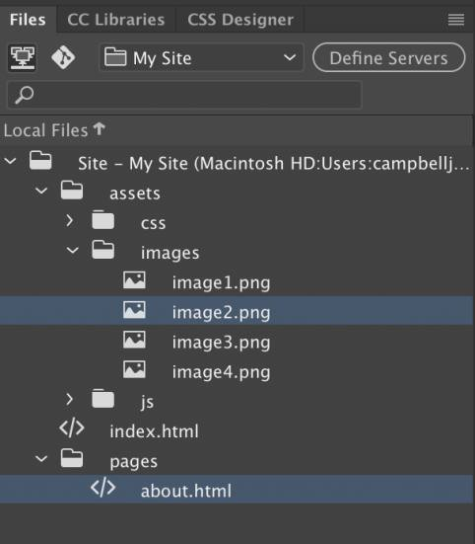You want to place the file image2.png on the about.html page. Using the file structure shown, fill in the blanks to write a **site root relative** and a **document relative** file path for that image. (3.08)

|  |
| --- |
| **Site root relative** |
| **/ images/image2.png** |
| **Document relative** |
| **../assets/ images/image2.png** |

1. Explain the principle of **accessibility** on the web. (3.09) Everyone should be able to view or access things on your website, so if their isn’t any alt text for people then it’s a concern.
2. What is **alt-text** and why is it important to maintaining accessibility? (3.09) used by screen reads to describe images aloud for the visually impaired. Also, will show when your image won’t load. It’s very important because you need this so everyone can use your website.
3. In what Dreamweaver panel can you easily add alt-text to your images? (3.09) Properties Panel
4. List the steps you need to take to run an alt-text report for every page in your site. (3.09) Sites > Reports > Missing Alt Text
5. What are the three types of video files supported by the <video> tag? (3.10) .mp4, .ogg, webm

# Dreamweaver CC18|19|20 Project 3 Checklist and Rubric

|  |  |
| --- | --- |
| **PROJECT 3 SPECIFICATIONS** | |
| * Create a Dreamweaver template from the page you made in Project 2. * Use the template to create a new starter page for this gallery project. In your new page, create the following structures:   + A layout structure of 3 columns using the <div> tag.     - Place at least 3 images inside each column, and create a CSS rule to float the columns side-by-side.   + Develop two media queries for your page that change the column layout based on the size of the browser detected.     - On tablet-sized browsers, the columns should display two at a time.     - On mobile-sized browsers, the columns should all display stacked on top of each other.   + Create a modified navigation menu for your mobile media query so that the buttons are easier to tap with a finger on a mobile display.   + Add your own images to the gallery placeholder files, or find images from the internet that reflect your interests. For the best appearance, crop your images so they are all the same dimensions before you add them to your page.   + Add alt-text to all images to ensure your webpage is accessible to those with visual impairments.   + Create a video slideshow of your images and add it to your page using the <video> tag. * For Video 3.04, follow along with your own copy of the csspositioning.html file. * As you create your page, be sure to keep up with the following tasks:   + manage your site folder by naming images and folders properly and keeping links organized.   + Use CSS to style the elements of your page in a visually attractive manner that represents your personality and interests. | **Site folder should have:**   * /my_portfolio   + /images     - all images   + /pages     - about.html     - blog.html     - gallery.html   + /assets     - styles.css   + /templates     - template.dwt   **You should be able to:**   * Create Dreamweaver templates and add editable regions. * Move files and create folders using the Files panel. * Position HTML elements using the CSS properties float and position. * Create media queries to make a webpage responsive * Replace placeholder images with other files * Add alt-text to images and explain the principles of web accessibility. * Insert videos using the   <video> tag. |

|  |  |  |
| --- | --- | --- |
| **Dreamweaver Project 3 “Image Gallery” Scoring Rubric** | | |
| ***Areas of Improvement*** | ***Criteria*** | **Evidence of Exceeding**  **Standards**  *Your teacher can provide feedback in this column to point out areas where you have demonstrated skill that goes above and beyond the basic criteria. Extra*  *Credit may be awarded.* |
| *Your teacher can provide feedback in* | *The basic requirements of the project are listed* |
| *this column to show you areas in your* | *in this column. If you meet these criteria, you are* |
| *skills that need improvement. Points may* | *right on track! Great job!* |
| *be deducted by your teacher from this* |  |
| *column.* |  |
|  | ***Page Content – 10 points***  Your page contains at least three columns, with at least three images in each column. |  |
|  | ***HTML and CSS Structure – 10 points***  The structure of your HTML tags and CSS rules displays correctly without any errors. Your code is written cleanly with spacing and indentation as appropriate. |  |
|  | ***Layout and Positioning***  Page elements are positioned correctly to avoid empty space and create good alignment and balance. Media Queries are used to change your column layouts in response to the size of the browser window. |  |
|  | ***Correct Images and Hyperlinks***  ***– 10 points***  All images display correctly, and all hyperlinks work. Images are appropriately sized within your page content with acceptable resolution. |  |
|  | ***File Management – 10 points*** All files (pages and images) and folders are named meaningfully and according to best practice (camelCase or hyphens, no spaces).  Files and folders are organized in an easy to understand manner. |  |
| **Total Score:** | | |

**Dreamweaver CC18|19|20 Project 3 Extension Projects**

## Project 3 Extension Challenges:

* Use Photoshop to learn how to crop and resize images for the web. Check out Project 1 from [BrainBuffet’s Photoshop course](http://www.brainbuffet.com/), specifically videos #5 and #8.
* Add captions underneath the images in your gallery. The trick is getting the captions and images to float together neatly!
* Extend your learning further with a quick tutorial on making image thumbnails enlarge when clicked. Check out this one from the W3Schools:<https://www.w3schools.com/howto/howto_js_tab_img_gallery.asp>
* Work on a free online course in HTML and CSS from Codecademy.com

## Project 3 Cross-Curricular Enrichment:

Students can continue whatever cross-curricular theme may have been started in Projects 1

and 2 and expand it to fit the “image gallery” project with images to illustrate their topic.